Mongo Db Task

1.db.products.find().pretty()

Lists all products

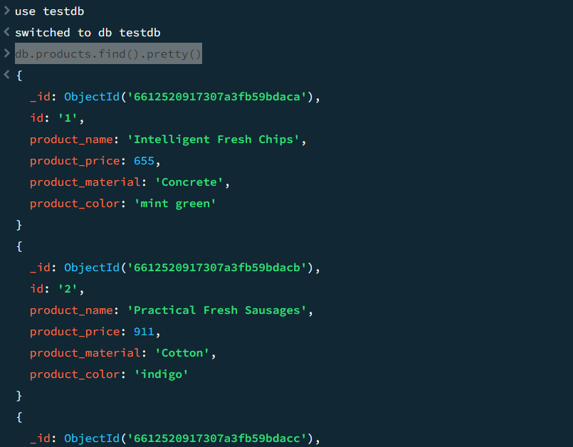

2. db.products.find({product_price:{$gte:400,$lte:800}})

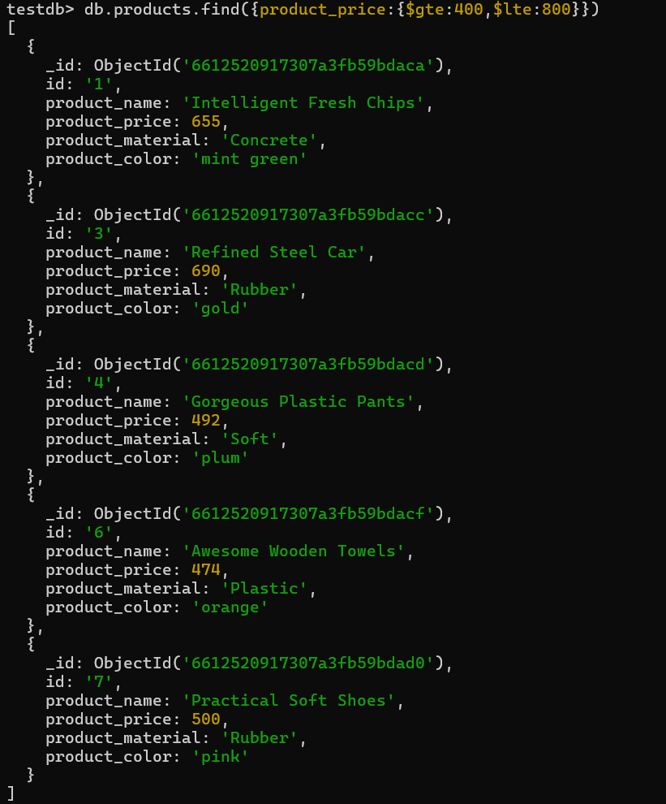

3. db.products.find({product_price:{$not:{$gte:400,$lte:800}}})

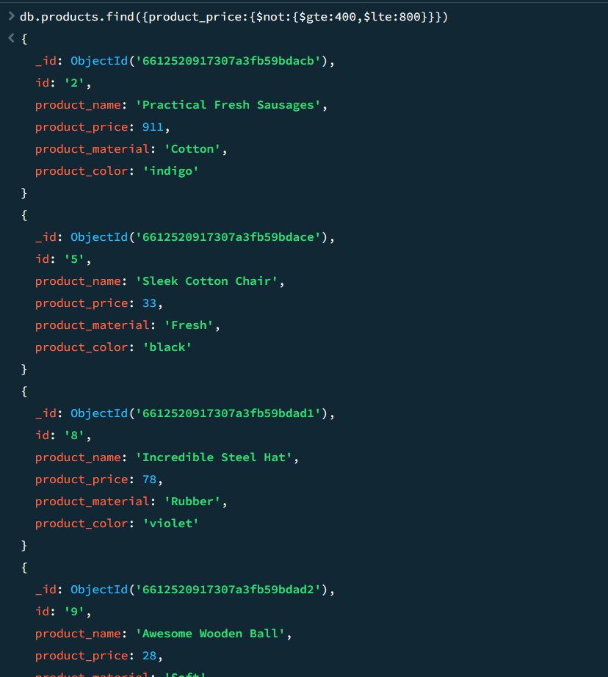

4.db.products.find({product_price:{$gt:500}}).limit(4)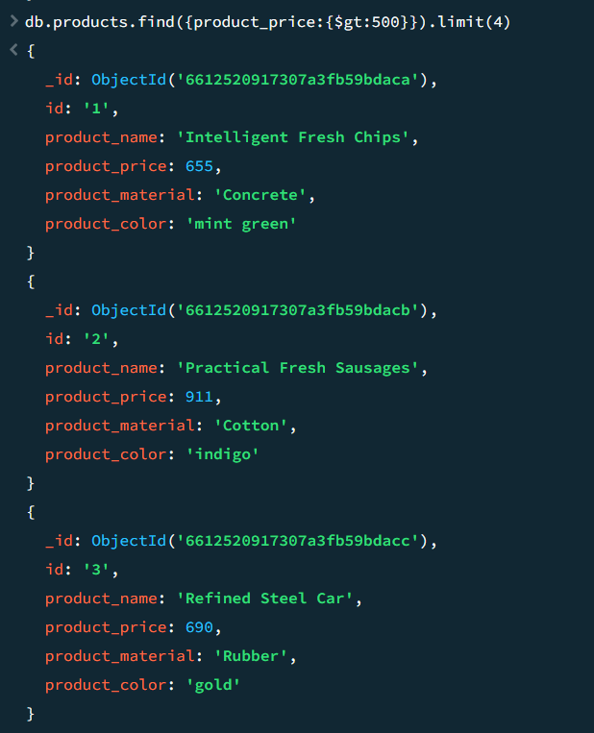

5. db.products.find({},{product_name:true,product_material:true})

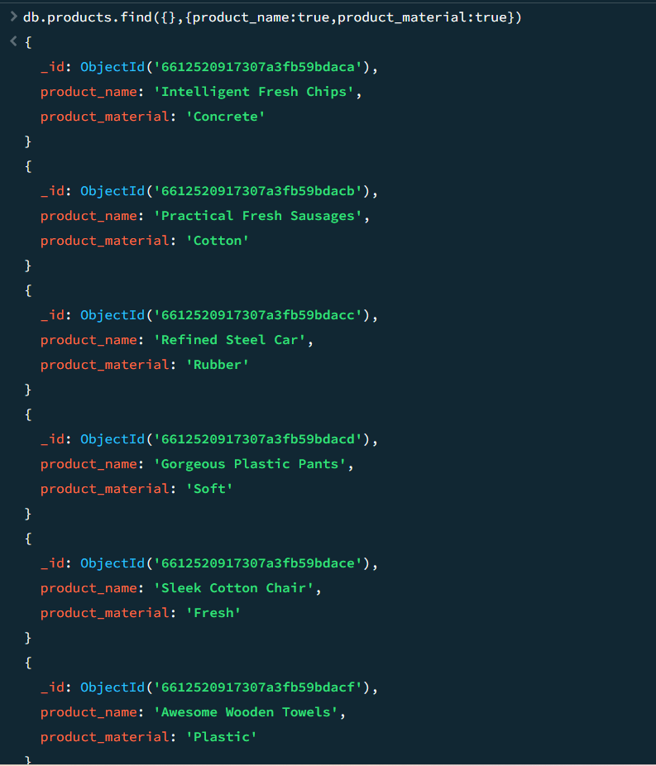

6. db.products.findOne({"id":"10"})

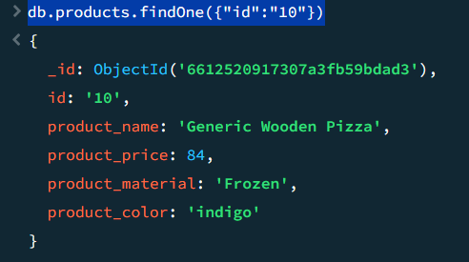

7. db.products.find({},{product_name:true,product_material:true,_id:false})

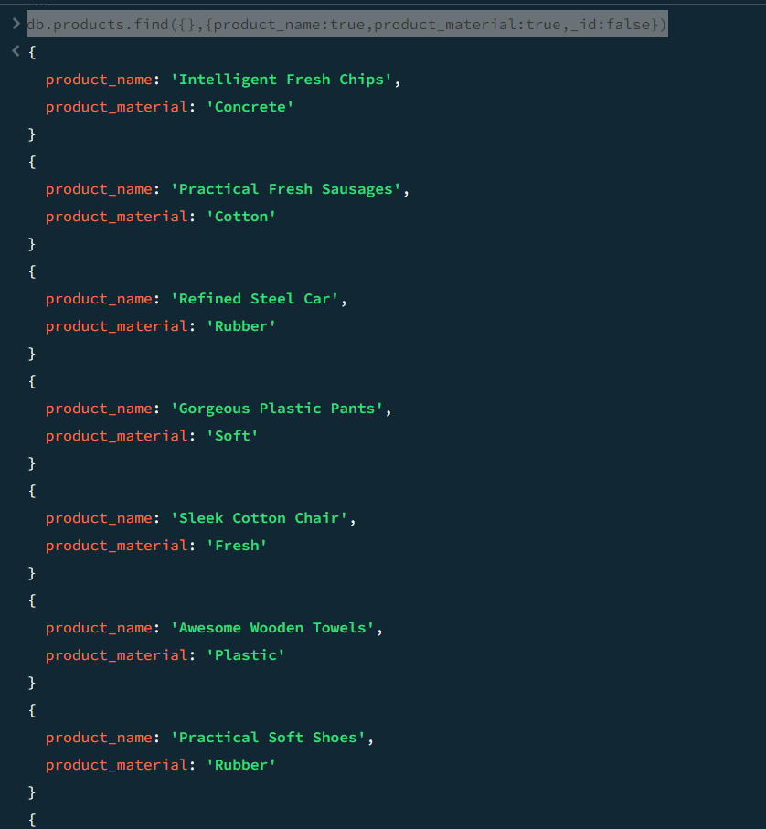

8. db.products.find({'product_material':'Soft'})

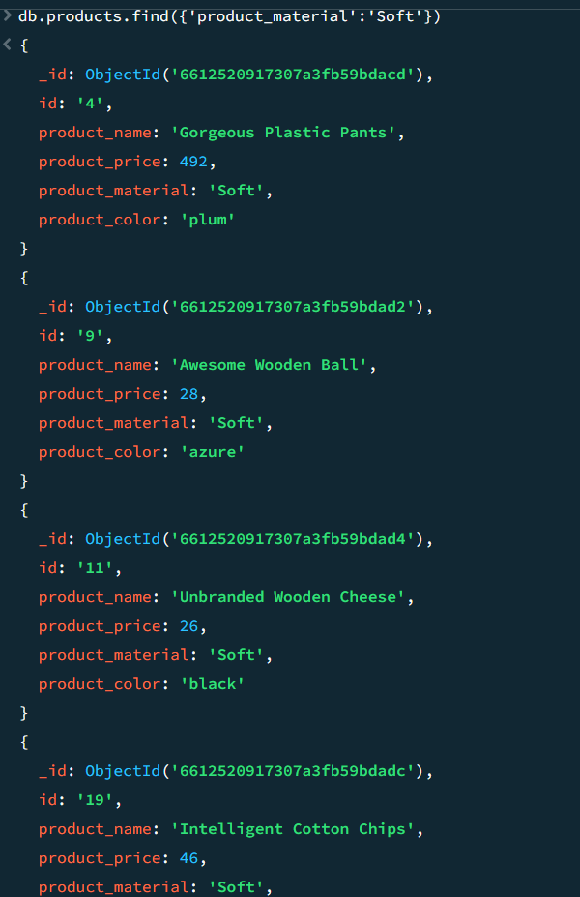

9. no product available

db.products.find({'product_color':'indigo','product_price':492.00})

(or)

db.products.find({ $and: [{ product_color: "indigo" },{ product_price: 492 }]});

10. db.products.deleteOne({product_price:28})

